<https://wireframe.cc/7VDoaG>

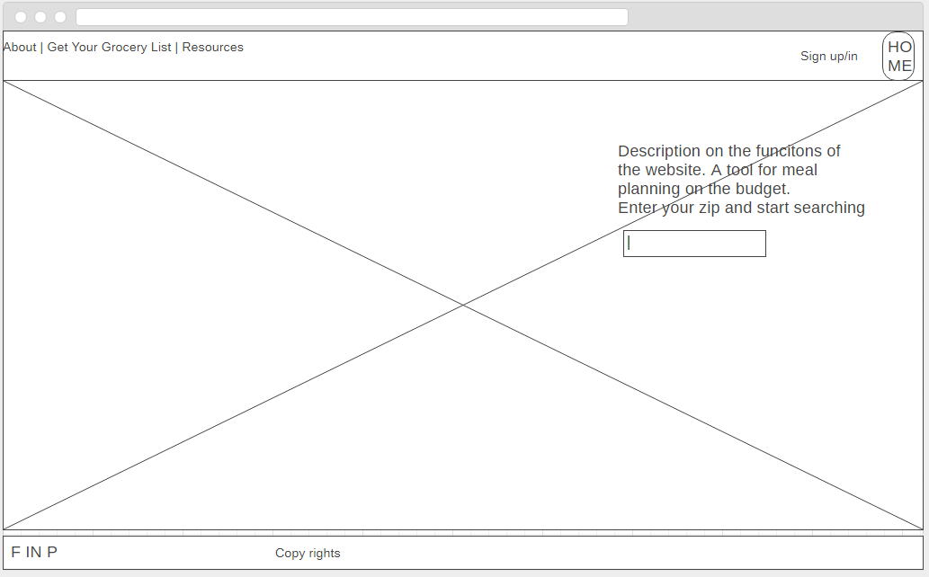

<https://wireframe.cc/SUD3bN>

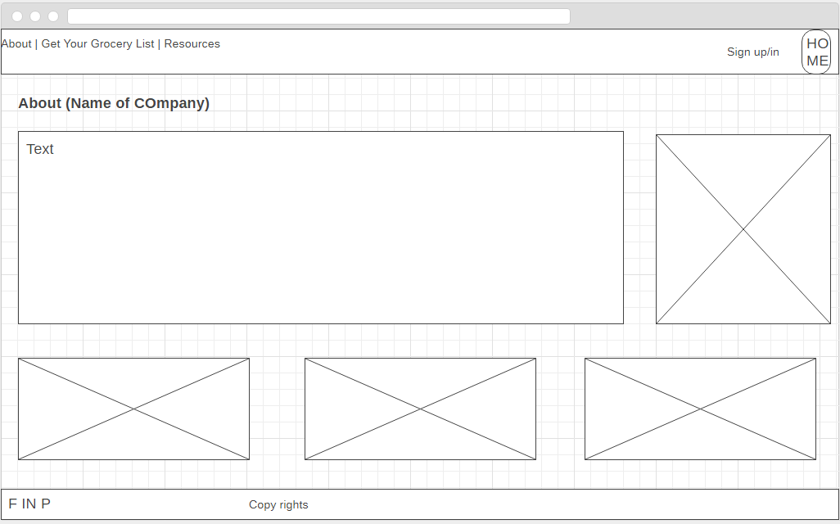

<https://wireframe.cc/Qi769m>

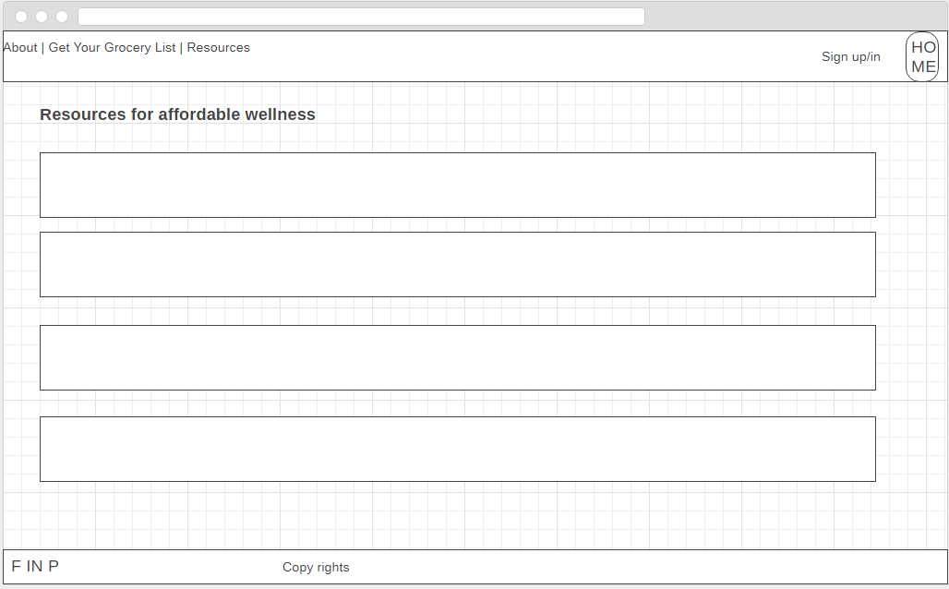

<https://wireframe.cc/tLOe7i>

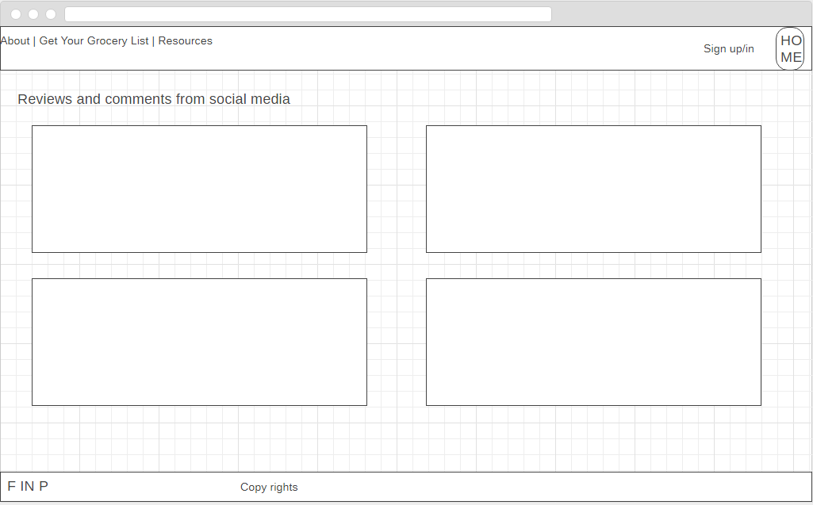

<https://wireframe.cc/qKuesS>

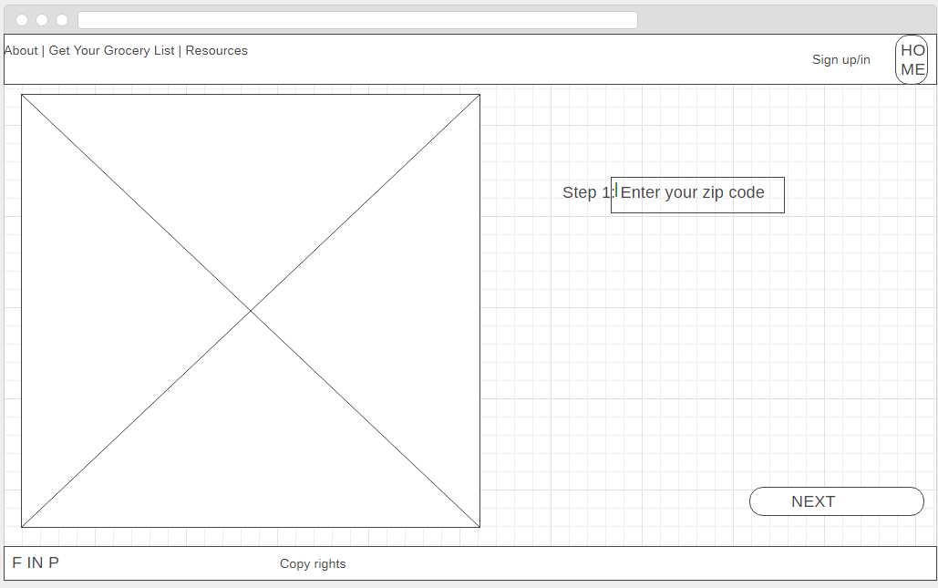

<https://wireframe.cc/UUCoUG>

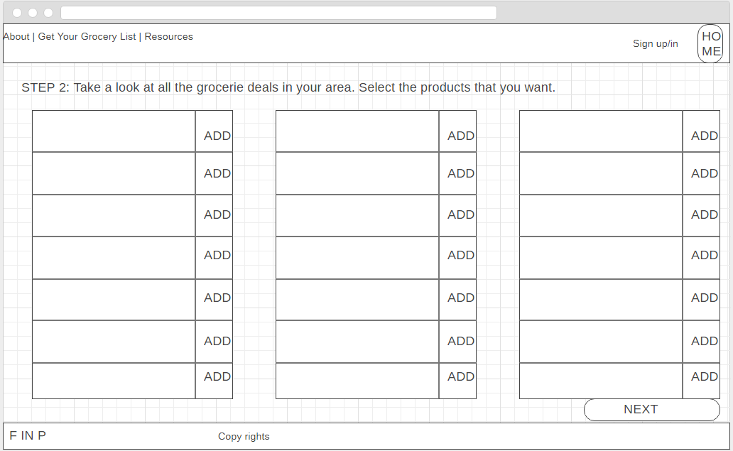

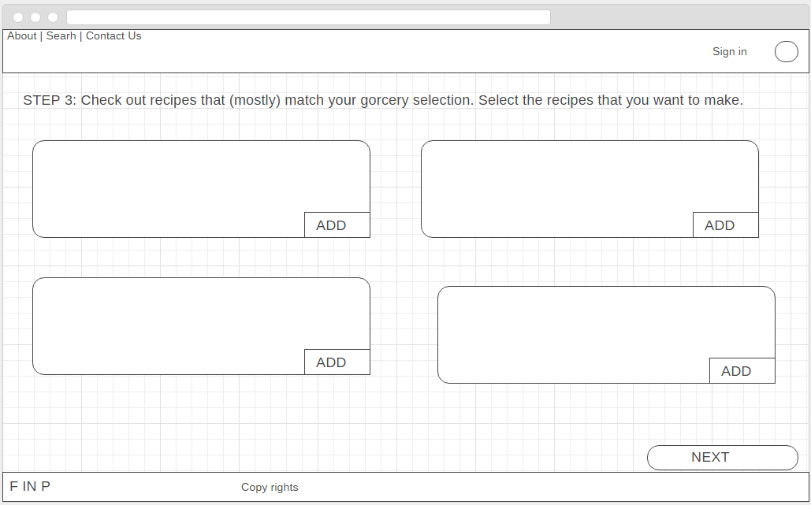

<https://wireframe.cc/eEFaOK>

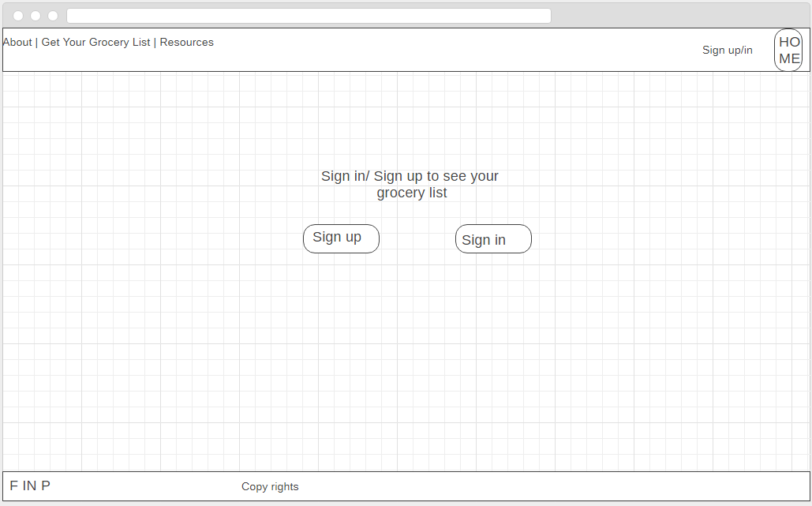

<https://wireframe.cc/QhnKtB>

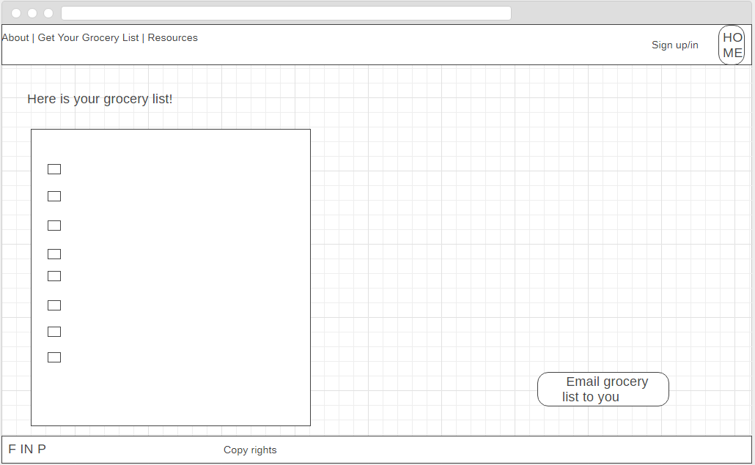

<https://wireframe.cc/8neurs>

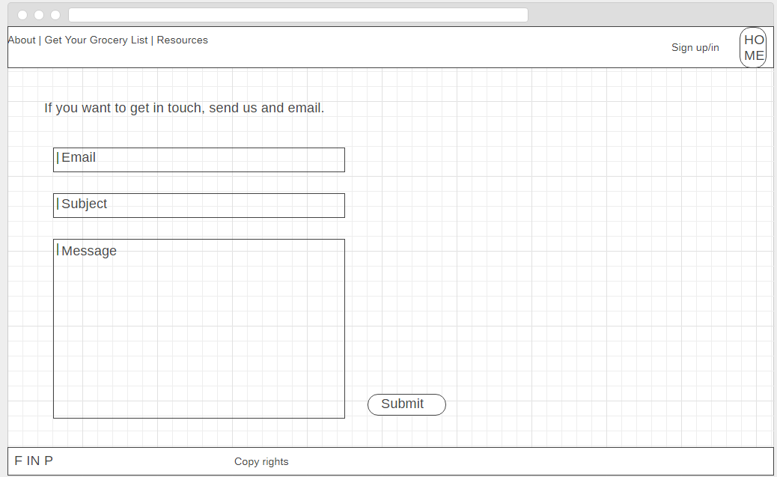

<https://wireframe.cc/kowAcg>

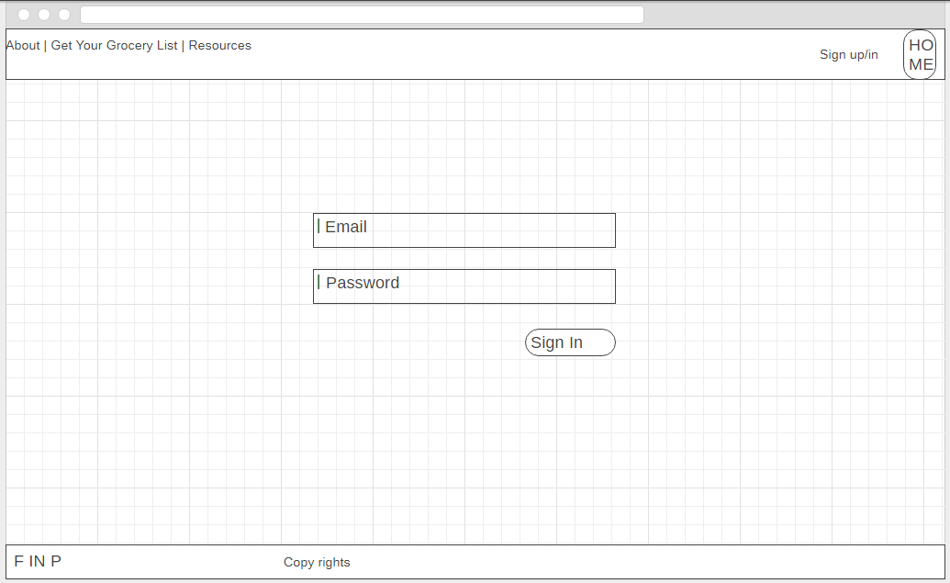

<https://wireframe.cc/B7qBcO>

